CG PRACTICAL QUESTION BANK

Shift the origin to the center and implement the following

1. DDA line drawing (print all the pixels in console )
2. Bresenham line drawing algorithm (m<1) print points in console
3. Bresenham line drawing algorithm ( m>=1 ) print points in console
4. Draw the following pattern using DDA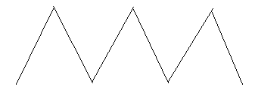
5. Draw the following patterns using midpoint circle algorithm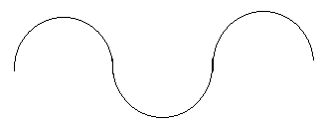
6. Draw the following patterns using midpoint circle algorithm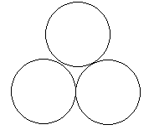
7. Draw the following patterns using midpoint circle algorithm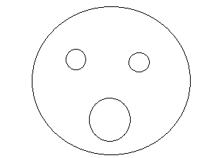
8. Translate a square
9. Translate a circle
10. Translate a ellipse
11. Translate a triangle
12. Rotate a square about a fixed point
13. Rotate a circle about a fixed point (draw a line across the circle a reference)
14. Rotate a ellipse about a fixed point
15. Rotate a triangle about a fixed point
16. Rotate a square about the origin
17. Rotate a circle about the origin(draw a line across the circle a reference)
18. Rotate a ellipse about the origin
19. Rotate a triangle about the origin
20. Scale a square about the origin
21. Scale a ellipse about the origin
22. Scale a circle about the origin
23. Scale a triangle about the origin
24. Scale a square about a fixed point
25. Scale a circle about a fixed point
26. Scale a ellipse about a fixed point
27. Scale a triangle about a fixed point
28. Generation of a fractal (tree)
29. Generation of Bezier curves

**Note:- For Transform use the in-build function to draw the object, because the objective is to perform transformation.**